

Glenfield PTO

**Clothing Order Form 2018**

We’re offering new South Lewis school spirit apparel (which will also count on spirit day)! If you would like to purchase items, complete the order form and return it to school **WITH PAYMENT.** If paying by check, please make checks payable to: **Glenfield Elementary PTO**. All order forms, along with your payment, should be returned to school no later than **November 2nd**. Any questions, please contact Heather LeVan at 315-348-2625 or [hlevan@southlewis.org](mailto:hlevan@southlewis.org).

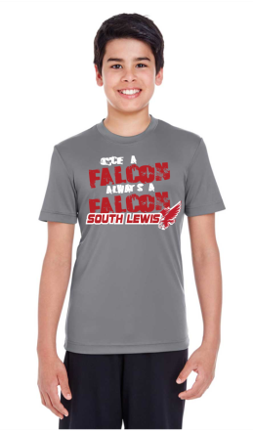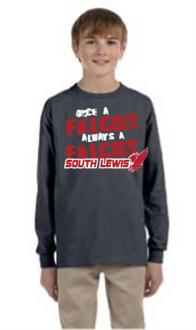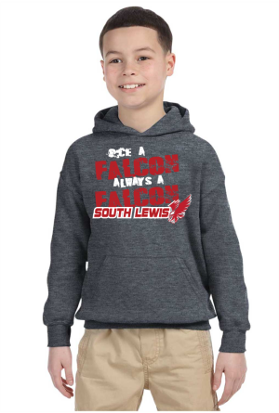 **1-2** **3-4 5-6 7-8 9-10**

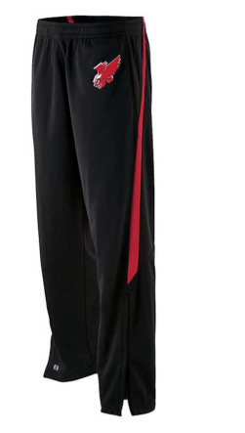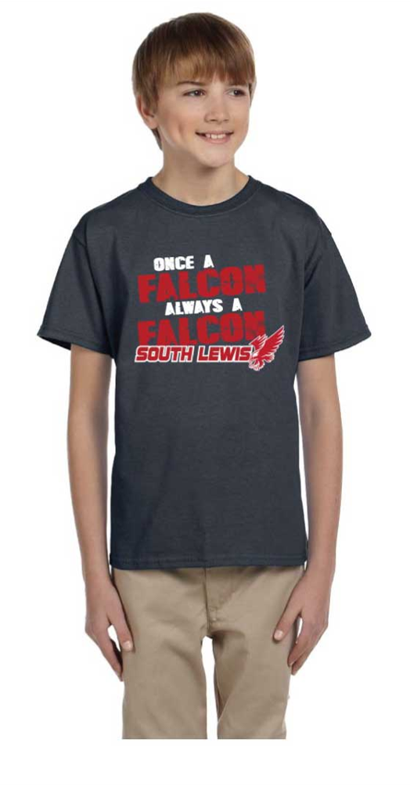

Charcoal

Charcoal

Sport Graphite

Dark Heather

*All shirts are grey with red and white screen print. Pants are black with red stripe and embroidered falcon*

|  |  |  |  |  |  |  |
| --- | --- | --- | --- | --- | --- | --- |
| **#** | **Description** | **Sizes** | **Quantity** | **Size** | **Price** | **Subtotal** |
|  |  |  |  |  |  |  |
| **1** | G200B Youth Cotton T-Shirt | XS-XL |  |  | $9.00 |  |
| **2** | G200 Adult Cotton T-Shirt | S-5X |  |  | $9.00 |  |
| **3** | TT11Y Youth Dri-Fit T-Shirt | S-XL |  |  | $12.00 |  |
| **4** | TT11 Adult Dri-Fit T-Shirt | XS-4X |  |  | $13.00 |  |
| **5** | G240B Youth Cotton Long Sleeve Shirt | S-XL |  |  | $15.00 |  |
| **6** | G240 Adult Cotton Long Sleeve Shirt | S-5X |  |  | $16.00 |  |
| **7** | Youth 50/50 Hooded Sweatshirt | XS-XL |  |  | $20.00 |  |
| **8** | Adult 50/50 Hooded Sweatshirt | S-5X |  |  | $22.00 |  |
| **9** | 229243 Youth Sweatpants | S-XL |  |  | $32.00 |  |
| **10** | 229143 Adult Sweatpants | S-3X |  |  | $34.00 |  |
| **Total Due** | | | | | |  |

Name: ___________________________________Phone/Email: __________________Grade/Teacher:_______________

Orders are expected to go home by the end of November. Please check here if you would like to **PICK UP** **the items**____

**Or SIGN HERE if you would like us to send the items home with your student**__________________________________